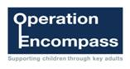
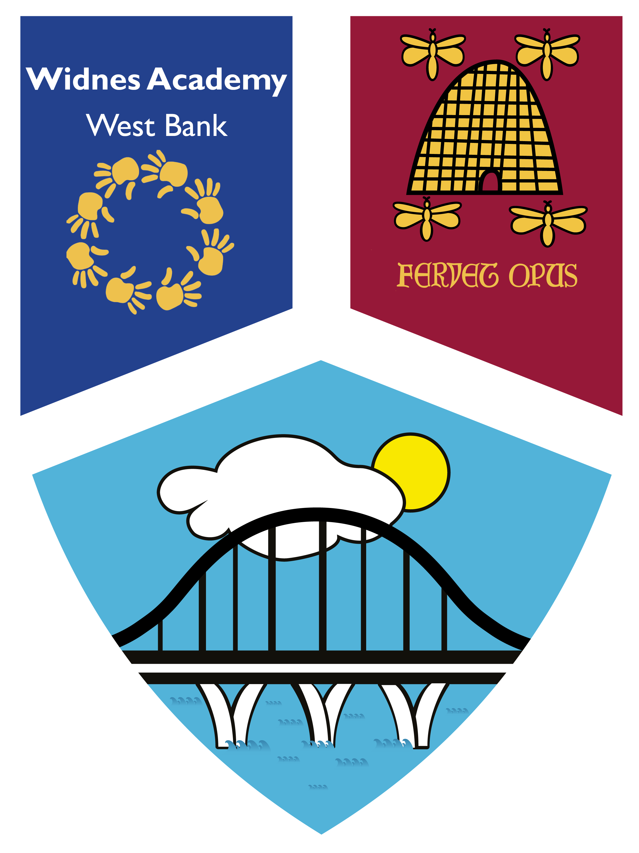

Dear Parent / Carer
I am writing to inform you that our school participates in a Police led initiative called Operation Encompass. This is a partnership between schools and the Police that helps schools to better support any child where a domestic incident has been reported to Police from their home.
Following a domestic incident, the Police will make contact with the child’s school via telephone and secure email (usually the next day) and will communicate relevant information to nominated, fully-trained school staff. to communicate relevant information to a nominated, fully-trained member of school staff. This will ensure that as a school, we are made aware early enough, to support children and young people in a way that means they feel safe, supported and listened to. It will also provide an opportunity for school to offer support to the whole family
Each school has 2 members of staff called key adults who are trained to liaise with the police, when required, whilst ensuring support is available to the child.
The initiative was launched county-wide at the beginning of 2016. It is active in all Cheshire schools. You can find out more about Operation Encompass via the following site: http://www.operationencompass.org/

If you would like to speak to someone further about the initiative, or require any additional information, please do not hesitate to contact either Mrs Highcock or Mrs Harrison.
We are committed to working in partnership with local relevant organisations to keep children safe and to offer valuable support to all children across Cheshire.
Yours faithfully,
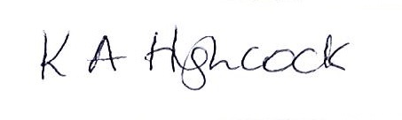
Mrs K A Highcock
Principal, Widnes Academy


