11th May 2020

Dear Parents and Carers,
I’m sure that after the Prime Ministers statement yesterday you have lots of questions about what will happen next. We also have lots of questions that need clarification.
At the moment, for us in school, there is no change to the guidance. We will continue to provide care for children of Key Workers and our vulnerable pupils.The message is still that it is safer to stay at home.
We have not received any information to support us with this new plan to start the phased re-opening of school for some year groups to start on 1st June. We expect we will receive further information from the DfE shortly, hopefully with some clarification.
We will need clear guidance to plan how it is possible to social distance in schools and keep our children, teachers and families safe; how we might start to phase groups of children returning and what this looks like. Please be assured there is no way we will reopen until we are 100% prepared.
As always, we will keep you informed but for now, please try not to worry. Our plan for now is to continue to provide activities for learning at home, keep in contact with you and continue to support each other in these very difficult and uncertain times.
Stay safe
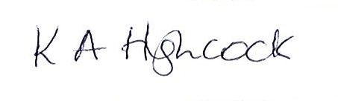
Mrs K Highcock
Principal

